  - Product No and Unit price are overlapping with each other
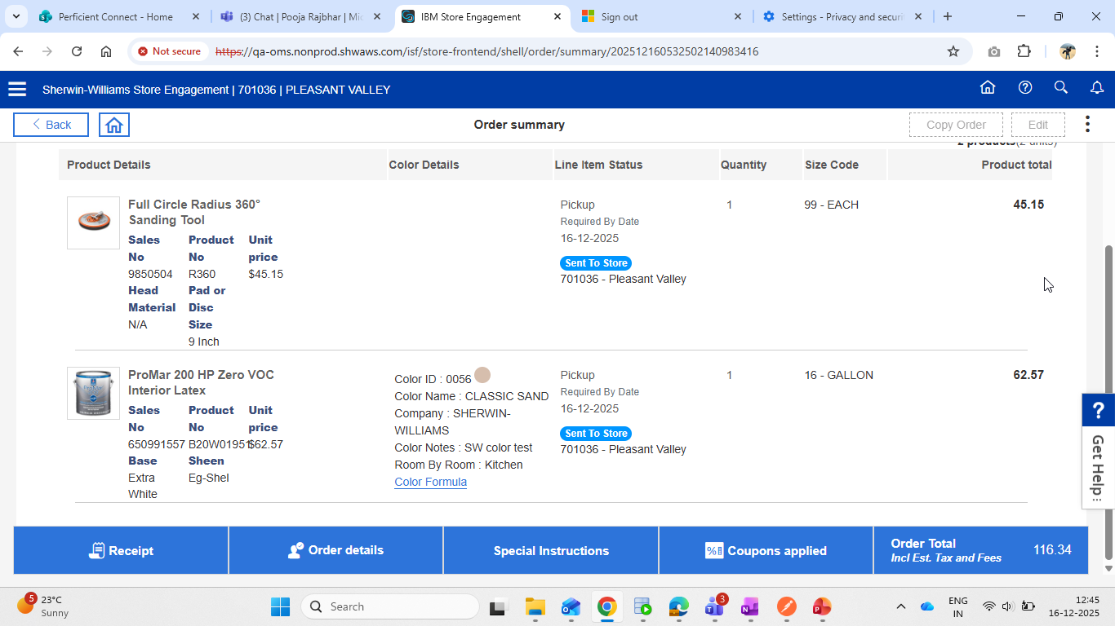

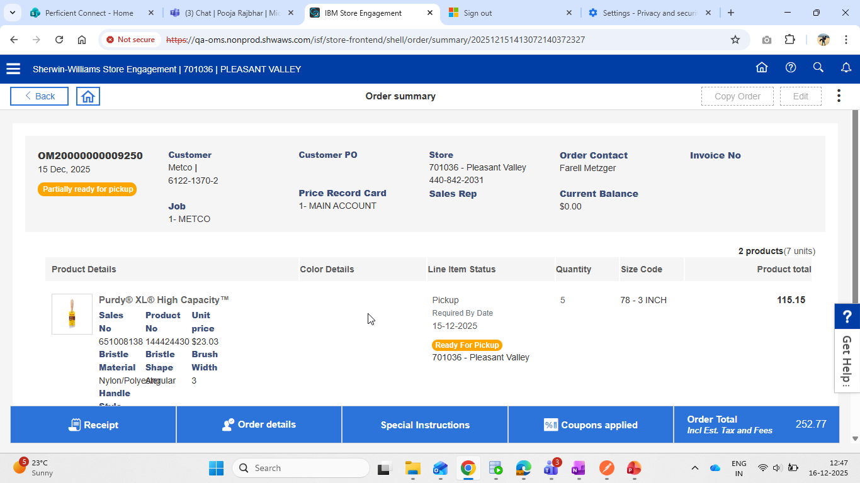

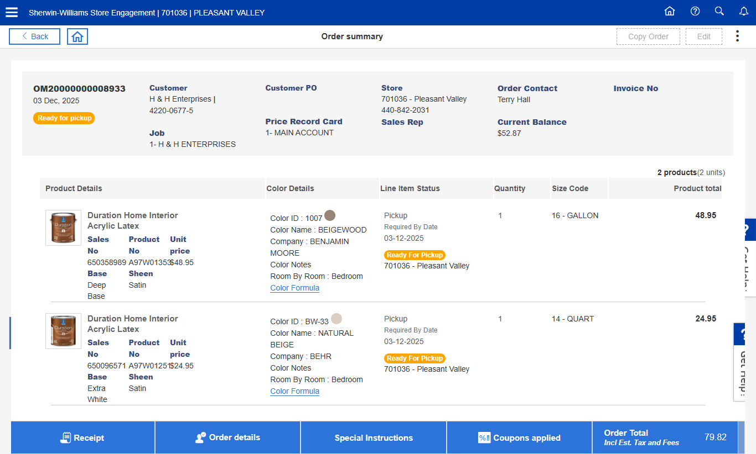

  - My Order Portlet - When applied Filters with no matching results taking too much time to load
  - My Order Portlet -- Page is giving no matched order , When applied product description filter with only one keyword . Ex-Latex , Acrylic - OMSV-5434
  - Closed Order - Filter with Color Id , Color name and Color type showing non tinted , Regular items containing orders
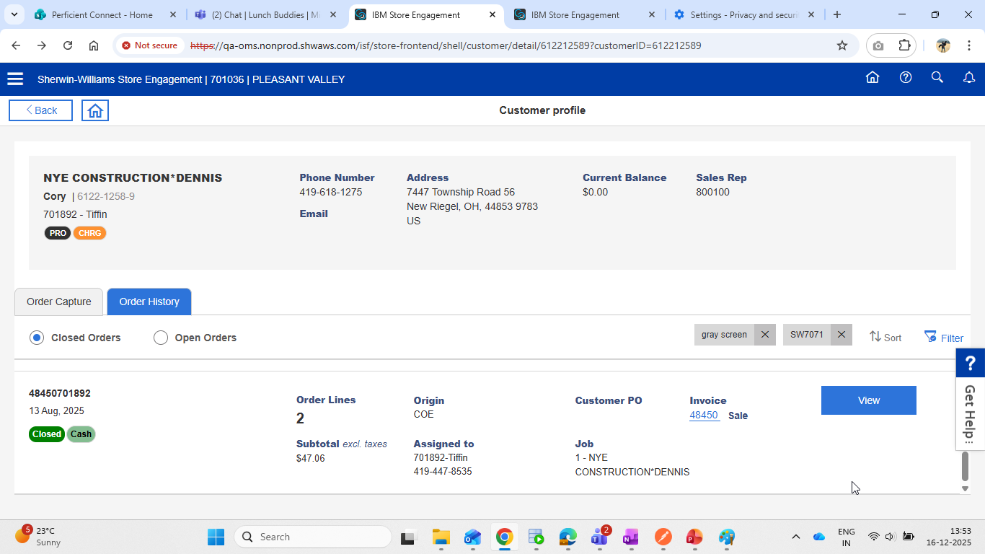

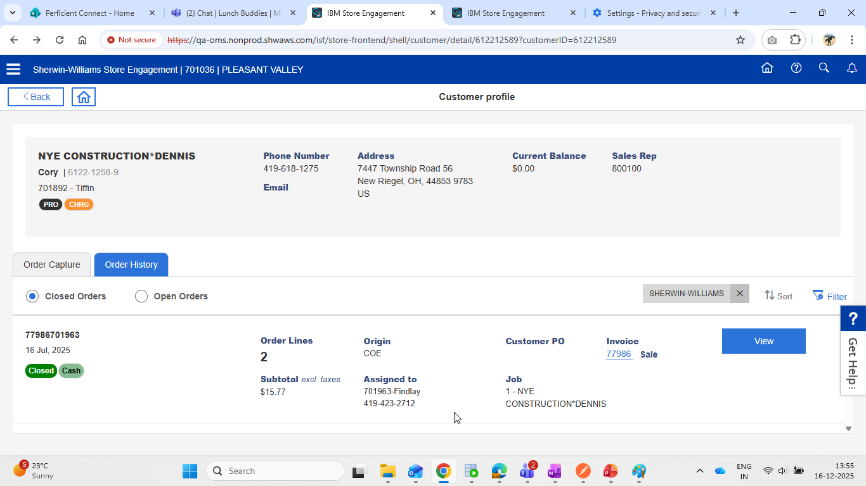

  - Closed order - Minimum Transaction amount filter not working as expected
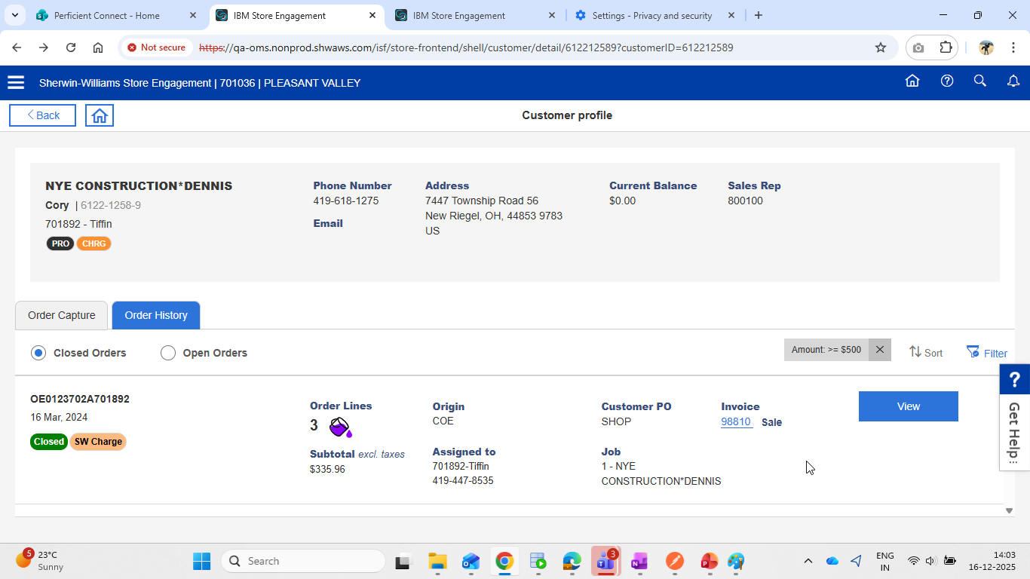

  - Closed Order - Rex No and Sales No filters not filtering orders as expected
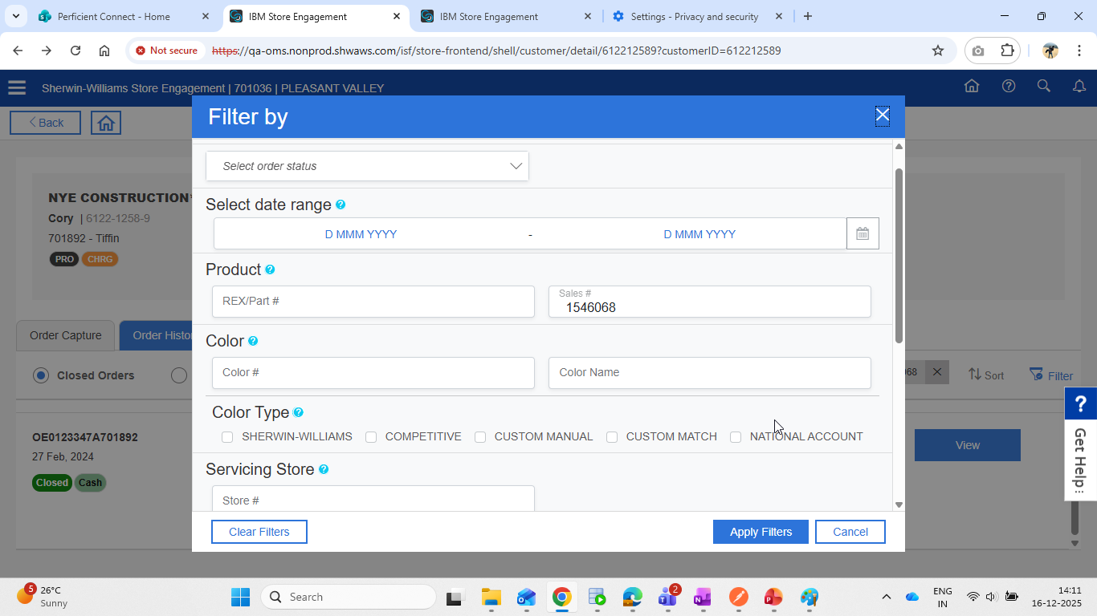

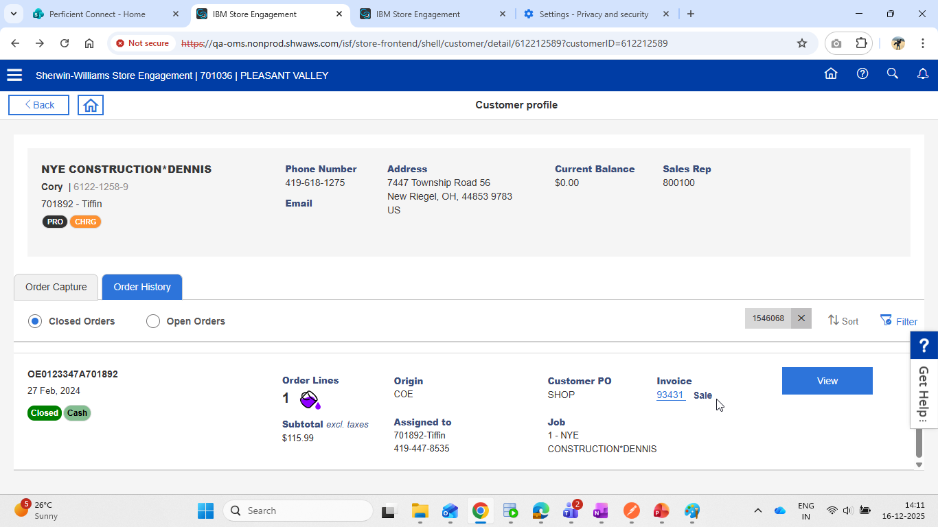

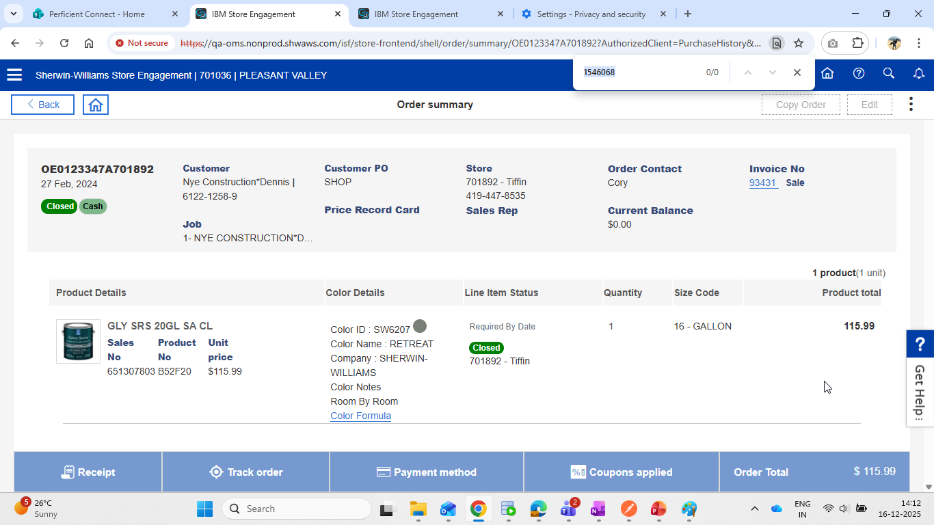

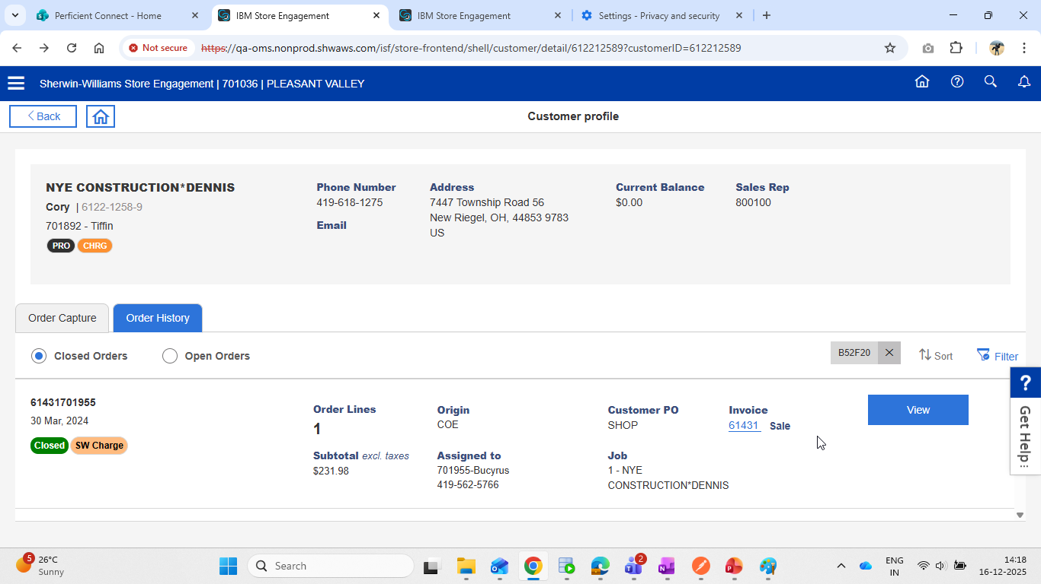

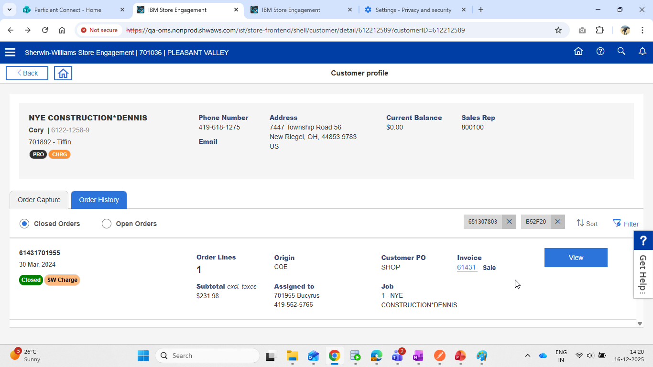

Question -
1. Why we are restricting PO filter to min 3 characters , as in PO we are allowing that

